Can you call me now? (Instructor Version)

**Instructor Note**: Red font color or Gray highlights indicate text that appears in the instructor copy only.

1. Objectives

Calculate the necessary subnet mask in order to accommodate a given number of hosts.

Subnetting is hierarchical and can help deliver network traffic more easily if small groups of IP addresses are designed to serve network needs.

1. Background /Scenario

**Note:**  This activity may be completed individually or in small/large groups using Packet Tracer software.

* + You are setting up a dedicated, computer addressing scheme for patient rooms in a hospital. The switch will be centrally located in the nurses’ station, as each of the five rooms will be wired so that patients can just connect to a RJ45 port built into the wall of their room. Devise a physical and logical topology for only one of the six floors using the following addressing scheme requirements: There are six floors with five patient rooms on each floor for a total of thirty connections. Each room needs a network connection.
  + Subnetting must be incorporated into your scheme.
  + Use one router, one switch, and five host stations for addressing purposes.
  + Validate that all PCs can connect to the hospital’s in-house services.

Keep a copy of your scheme to share later with the class or learning community. Be prepared to explain how subnetting, unicasts, multicasts and broadcasts would be incorporated, and where your addressing scheme could be used.

**Instructor Note**: This Modeling Activity may or may not be a graded assignment. Its purpose is to check students’ mastery of hierarchical subnets and subnet masking operation. A facilitated chapter review discussion can be initiated as a result of this activity.

1. Required Resources

* Packet Tracer software

1. Reflection
2. How would you change your addressing scheme if you were going to add an additional network connection to the hospital rooms with a total of 10 connections per floor or 2 ports per room?

____________________________________________________________________________

If the number of network connections were doubled, a subnet mask of 255.255.255.240 with a prefix of /28 would be necessary to support connectivity.

Another possible solution to the original activity might be:

1. 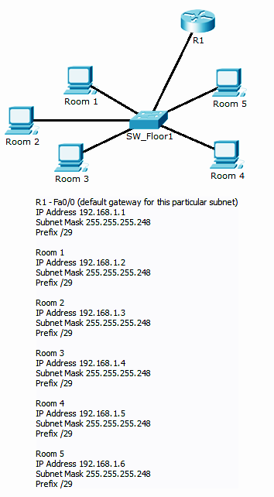

**Identify elements of the model that map to IT-related content:**

* Hierarchies are employed when using addressing schemes. The hospital’s floors represent subnetworks and the patient connections represent host addresses.
* Connectivity is influenced by the addressing scheme identifiers. The switch represents a valid intermediary device for data processing between statically addressed end devices.